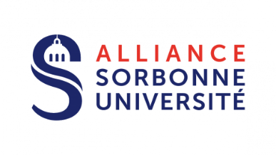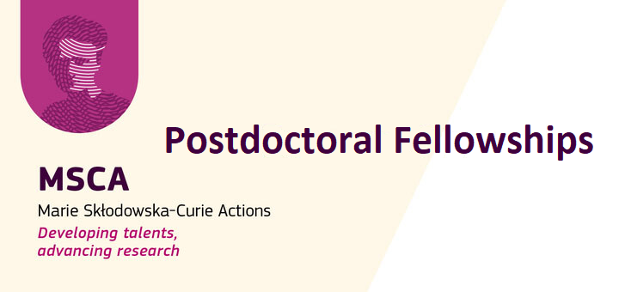

CALL FOR APPLICATIONS 2025 – FELLOWS

|  |  |  |
| --- | --- | --- |
| Family Name  First Name |  | *answer here*  *answer here* |
|  |  |  |
| ORCID Number |  | *answer here* |
| Date of PhD Graduation |  | *answer here (DD/MM/YY)* |
| Title of PhD Thesis |  | *answer here* |
| Selected Project Title |  | *answer here* |
| Selected Project Supervisor |  | *answer here* |
| Country/countries of Residence (in the last 3 years as of Sept. 10th, 2025) |  | *answer here* |

DECLARATION OF ELIGIBILITY

*Researchers interested in submitting a Posdoctoral Fellowship:*

* *must be in possession of a doctoral degree or have successfully unconditionally defended their doctoral thesis before the call deadline*
* *must have a maximum 8 years (full-time equivalent) research experience from the date of award of the (first) doctoral degree*
* *must comply with the following mobility rule: they must not have resided or carried out their main activity (work, studies, etc.) in the country of the beneficiary (for European Postdoctoral Fellowships), or the host organisation for the outgoing phase (for Global Postdoctoral Fellowships) for more than 12 months in the 36 months immediately before the call deadline*

I hereby declare that I am eligible to the Marie Skłodowska-Curie Actions Postdoctoral Fellowships 2025, as per the European Commission’s eligibility criteria mentionned above and on the [official website](https://marie-sklodowska-curie-actions.ec.europa.eu/actions/postdoctoral-fellowships).

Date : Signature :

To submit your application, please send an email with the required documents to

[msca-pf@sorbonne-universite.fr](mailto:msca-pf@sorbonne-universite.fr)