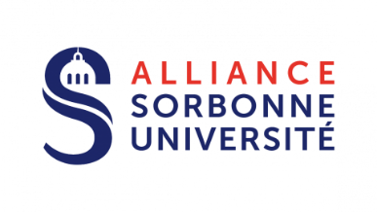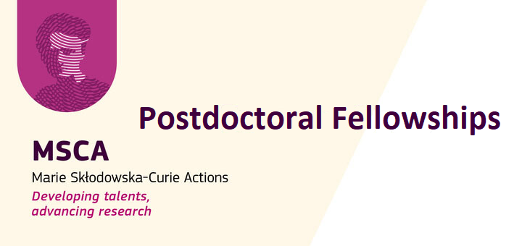

CALL FOR APPLICATIONS 2025 – FELLOWS

|  |  |  |
| --- | --- | --- |
| Family Name  First Name |  | *answer here*  *answer here* |
|  |  |  |
| ORCID Number |  | *answer here* |
| Date of PhD Graduation |  | *answer here (DD/MM/YY)* |
| Title of PhD Thesis |  | *answer here* |
| Selected Project Title |  | *answer here* |
| Selected Project Supervisor |  | *answer here* |
| Country/countries of Residence (in the last 3 years as of Sept. 10th, 2025) |  | *answer here* |

DECLARATION OF ELIGIBILITY

*Researchers interested in submitting a Posdoctoral Fellowship:*

* *should have a PhD degree at the time of the deadline for applications*
* *must have a maximum of eight years experience in research, from the date of the award of their PhD degree (for exceptions, refer to the MSCA-PF Guide for Applicants)*
* *must not have resided or carried out their main activity in France for more than 1 year in the 3 years immediately before the call deadline*

I hereby declare that I am eligible to the Marie Skłodowska-Curie Actions Postdoctoral Fellowships 2025, as per the European Commission’s eligibility criteria mentionned above and on the [official website](https://marie-sklodowska-curie-actions.ec.europa.eu/actions/postdoctoral-fellowships).

Date : Signature :

To submit your application, please send an email with the required documents to

[msca-pf@sorbonne-universite.fr](mailto:msca-pf@sorbonne-universite.fr)